

**(SS113)-Pakistan Studies**

**Harassment: An Alarming Social Dilemma and Challenge for**

**Pakistan.**

**Group Members**

**Abdullah Basit 20I-0623**

**Rida Kamal 20I-2496**

**Ahmed Hameed Khan 20I-0532**

**Waleed Zafar 20I-2369**

**Iqra Zafar 20I-2401**

**[Semester 1 Report 2020]**

**(SS-113)-Pakistan Studies**

***Table of Contents***

Introduction 3

Street Harassment 3

Prevalence of street harassment in Pakistan 3

Stigma surrounding conversation of street harassment in Pakistan 4

Conclusion 4

Sexual Harassment 5

Sexual Harassment and Pakistan 5

Why does no one talk about it? 5

Laws in Pakistan 6

Prevention 6

Religious Harassment 7

Violence and persecution about religious 7

Violence and persecution about Racial Harassment 8

Cyber Harassment 9

Forms of Cyber harassment in Pakistan 9

Deepfake 9

Denial of Service 9

Hate Speech 10

Online Sexual Harassment 10

Consequences of Cyber Harassment 10

Reporting Cyber Harassment in Pakistan 11

Psychological Harassment 11

Forms of Psychological Harassment 11

Workplace Psychological Harassment 11

Psychological Harassment in Educational Institutes 12

Effects of Psychological Harassment 12

Harassment – A new norm in Pakistan 12

Conclusion 13

Bibliography 13

Introduction

Harassment in Pakistan is a major issue that affects people of all ages and categories. It is fairly common for women and transgenders to be the target of such attackers, though men are also prey to these harassers. Although there are various different types of Harassments observed in Pakistan, the 5 most common include:

1. Street Harassment
2. Sexual Harassment
3. Religious Harassment
4. Cyber Harassment
5. Psychological Harassment

Street Harassment

Street harassment comprises of unsolicited comments, signals, and actions forced on a stranger in a very public place empty their consent and are rapt at them thanks to their authentic or apparent gender expression. Street harassment comprises of unasked for hooting, ogling, sexist slurs, persistent requests, stalking, cat calling names, commentaries and demands, following, flashing, groping, regulatory offence, and rape.

Prevalence of street harassment in Pakistan

While street harassment has developed into a deeply disturbing issue in Pakistan, no proactive efforts are made to gather or compile data of this portent. A recent example is that the Motorway Case, where the poor lady was victim blamed by the CCPO, himself. 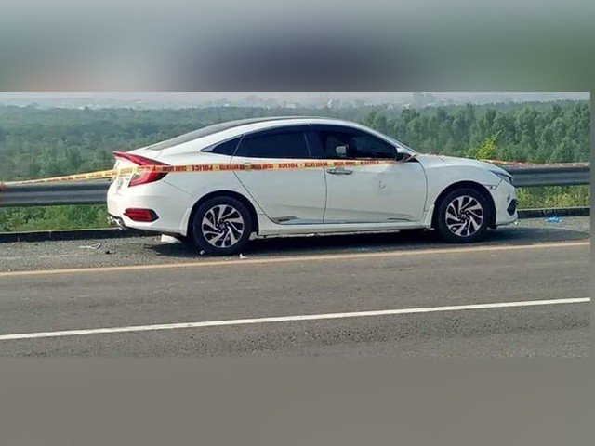This utterly disturbing system has to be challenged and this social dilemma will only be proscribed rightly if we together raise awareness regarding it, be vigilant of our roles as a member, and men specially be protective of the ladies in their environment and speak up rather than being enablers. We contend that teachers could play an important role in educating the youth to assist decrease the road harassment, the govt. of Pakistan must provide them with the resources to hold out awareness and protection campaigns, self-defense institutes etc. should be focused upon instead. The abysmal sickness of street harassment runs so deep but casually that always we see people frowning upon its victims which are deeply irresponsible folks as citizens of Pakistan, which is that the land of pure.

Image 1: Morning after the Motorway Rape Case

Stigma surrounding conversation of street harassment in Pakistan

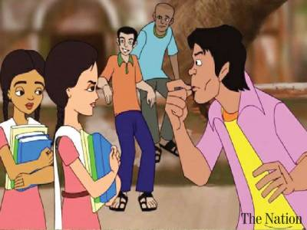Maria, 24, recently completed her Bachelor’s degree in media reportage from the University of Lahore, located in the middle of Lahore. She wears a black fully opaque gown and claims that she has never been harassed just casually cat called, or ogled and stared at but never touched. She does not even, consider this sheer disgust of behavior harassment that is the level of shame and unawareness attached with it in Pakistan This dialogue extract shows just how sickening and discussing matters of street harassment in Pakistan is, the shame surrounding it makes vocalization and talking about the experience so hard and whether or not victims gather they courage they're immediately clean up by this patriarchal system go past intergenerational shame. There are many ladies like Maria who don’t consider gaping, catcalling, unsolicited comments, and rough gestures a sort of harassment. It shows how communal these items became on the roadside in Pakistan. There must be immediate awareness of it so this sickness can halt or be reduced at least. The risks of street harassment in Pakistan are noxious, and alarming, as countless times, this verbal harassment turns physical. Whatever reasonably trouble it turns into, the victim prefers to remain hushed, thinking that it'll defame their last name if they disclose or report the incident. Many let these incidents go, this shame and stigma surrounding street harassment in Pakistan is what must be challenged, there should now not be space to let these monstrous criminals go, they need to be fought against by our society as an in depth knitted whole, intolerant to any sort of harassment, then only will we be true citizens of the land of Pure.

Art 1: Street Harassment. Credits: nation.com.pk

Conclusion

37%, of Pakistani adults say they'd not feel safe walking alone near their home at nighttime (Source: S3H). There has been an ever increase within the street harassment cases, and also to the intergenerational shame attached to that, it's about time we collectively raise our voices against it. As for the anti-harassment laws in Pakistan, a Defense against Harassment of ladies at Workplace Bill was approved in 2010 to be accountable for safer workplaces, office and court environments for ladies but the Pakistani Government is yet to pass a law which could shelter women against Street Harassment. it's extremely notable, and there should be a developing sense of urgency to deal with it. this will only be done when Street Harassment would actually be considered against the law to be limited from the society, and not the casual, stigmatized, and shunned topic.

Sexual Harassment

“Sexual harassment is the non-consensual and unwelcomed act done, physical or mental, in a sexual context to another person that leaves the victim disturbed and distress**.** “Usually when we talk about sexual harassment the word woman comes into our mind, we think that the only woman can be a victim of this offense but the reality is a bit different. Irrespective of any gender, even men have to face sexual harassment of all kinds. But in Pakistan, the percentage of men getting sexually harassed is pretty low.

Sexual Harassment and Pakistan

Pakistan is one of the few countries where cases reported each year are comparatively low. But it doesn’t mean that the actual occurrence of cases is low too. In fact, it is a lot higher than we ever thought if we look at the official figures from *Madadgaar National Helpline* and National Commission for Children around 70% of girls and women have experienced some sort of sexual violence by partners and around 93% of women and girls have faced the misconduct at public places. And what we see on television is just the tip of the iceberg. According to the founder of *Madadgaar* less than 10% of cases of sexual violence are reported on TV in Sindh and Punjab and this percentage is far low in Balochistan and KPK.

Why does no one talk about it?

So, if the numbers are so high why aren’t we informed of it at all? Because of no one to talks about it. What happened? When happened? Who did it? no one is ready to answer these questions. Usually, this crime in Pakistan is kept hidden by the victim itself or the victim’s family due to the reasons like lack of awareness. People think that if they reported the case it will be bad for them and their family reputation and as a result, the instances of such cases keep on growing. In backward areas of Pakistan like South Punjab, Sindh, Fata cultural values are not that developed and usually, a woman is considered the sinner if she becomes the victim of such violence and crime and usually is told to remain silent. But in recent times a change is seen with the establishment of helplines that now at least a small percentage of victims have started to report the cases as data from Madadgaar national helpline tells that 14 cases of child abuse, 562 cases of harassment, and 10 cases of sexual harassment were reported in 2016.

Laws in Pakistan

So, the question now is how a victim of sexual or any kind of harassment in Pakistan could deal with the misconduct that happened to him/her. **Pakistan Penal Code (1860)** provides the laws that held the accused liable and sentenced with punishments like heavy fines, imprisonment, and even death. Such laws give the victim power to get justice.  
For example:

* According to **section 509,** if a person affects or insults the modesty of a woman either physically or mentally, the offender can be charged with imprisonment or a fine and even both. Wrongdoer could be sent to jail for up to 3 years and could be fined about 5lac rupee.
* Any person caught making the false accusation against the women could be punished with five years of imprisonment and a fine according to **Section 496C** of the Pakistan Penal Code.
* If a person is caught guilty of doing something that is vulgar or indecent is charged with imprisonment and a fine under **Section 354A** of the Pakistan **Penal Code (1860).**
* According to **Section 366A** of the **Pakistan Penal Code (1860),** if a person is found guilty of forcing a girl under eighteen to have sexual intercourse would be charged with a fine and up to 10 years of jail.

Prevention

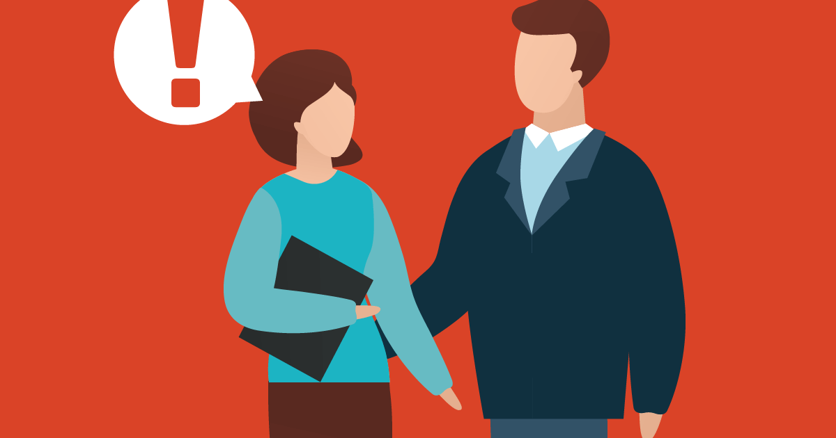Many of these cases can be prevented by spreading awareness, especially among females. First of all, everyone should be aware of all the rights and laws that are mentioned above so that when someone falls victim to such an offense, he/she could report it to the right authorities. Secondly, our children should be given basic sex education like what a bad touch and good touch are. How to identify sexual acts? Who to tell when something suspicious happens? And primitive families have to also upgrade their thinking that if they report the case it will be of no harm to their reputation but it could provide justice to the victim and could also encourage others to come out and report such things. Also, at work places, such an environment should be created that chances of such instances should become less and less. People should be held accountable and replied with strong action so that in the future no one even tries to commit such an offense.

Art 2: Sexual Harassment in workplace

Religious Harassment

Mohammad Ali Jinnah, recognized as Pakistan’s Quaid-e-Azam, on the occasion of his first speech before the members of the Constituent Assembly of Pakistan in 1947, clearly declared that non-Muslim spend their lives in country despite of any fear; They are fully independent to spent their lives according to their religious, cast, race and color. Despite this, minorities in Pakistan continue to face harassment simply because of their religion or cast.

Violence and persecution about religious

In 1970s, many elements culminated to contribute to a rise in violent attacks against minority people in Pakistan. By the 1980s, violent sectarian attacks, especially targeting the Shia and Ahmadi communities, became ever more commonplace. One of the attacks that targeting the Shias, those against the Hazaras in Balochistan (a minority within the Shia people) are very remarkable. These attacks, which began during General Zia ul Haqq’s regime in the 1980s, have continued over the subsequent decades, exacerbated by the proliferation of anti-Shia armed groups such as Lashkar-e-Janggi (Leek), Al-Qaeda, and Tehreek-e-Taliban Pakistan. There are continuous attacks between January 2001 and October 2011, at least 386 murders of Hazaras were reported still, and these attacks continue today.

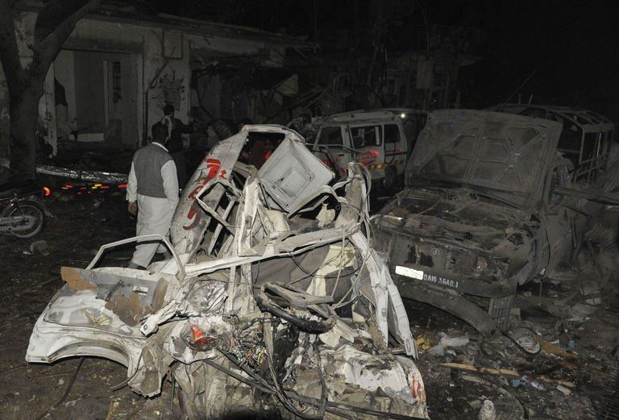 On 10 January 2013 attacks, more than 100 people were killed and 121 injured in twin bomb blasts in Quetta, that is the provincial capital of Balochistan. The attacks were supposedly committed by the LeJ. In Pakistan the Ahmadi communities are still target by violent attacks. These attacks are continuous on Ahmadi community, but the attacks against Ahmadis community have extremely increased since the 2000s when unknown men opened fire at an Ahmadi place of worship in a village in Sialkot. One of the largest attacks targeting Ahmadis took place on 28 May 2010, when a coordinated attack on two Ahmadi places of worship by the Tehreek-e-Taliban Pakistan and killed 80 peoples.

Image 2: Quetta Attack, Source: Dawn

Mostly minority community faces these issues like:

* Blasphemy laws
* Discriminatory employment policies
* Land grabbing and evacuee property
* Discriminatory personal status laws
* Discrimination in education
* Forced and coerced marriage

Over the past many decades, The Government of Pakistan is trying to resolve these issues but they fail. Here are some recommendations to the Government of Pakistan:

* Reforming legislation and government policies
* Fighting impunity
* Reforms in education
* Reforms in Media

Violence and persecution about Racial Harassment

Racial harassment is mostly discrimination the people on the basic of colorism and cast. In Pakistan racial harassment is mostly Colorism. What is history of this racial discrimination? In history mostly the people that rural on people of Pakistan are British and Mughal. They are mostly in light in color. After that physically we are free but mentally slaves of colorism. Media play an important role in promote the colorism. Mostly we see that adds encourage the white color. Mostly in social media like movies, dramas, commercial adds white color give the main or important role while black color give side or villain role. Mostly movies show that heroes and heroine are in white color and they are educated, civilized and well-manners. In contrast, black color give side or villain role and show that they are uneducated, uncivilized and have bad manners. Media also developed an idea in people’s mind about colorism.

In our society, Racism is very main social issue. People judge the intelligence on the basic of their color. People make their mind set that white in color are intelligent, hardworking, good manners, high ranked jobs, good communication skills and well-dressed. In Contrast, Black people are less intelligent, not have good manners, not qualified a high rank jobs, cannot talk others people with respect and even they are dressing sense. In Pakistan other issues are about race. People think that they are superior than others on the basis of Race. They do not like to give them respect as they required. Mostly married in their cast and race. This is a very prominent social issue in Pakistan about cast and race. As a Muslim we believe that there are no superior than others on the basic of color, race and cast. Our Holy Prophet Hazrat Muhammad (S.A.W) say in his last sermon about the color:

*“All mankind is from Adam and Eve; an Arab has no superiority over a non-Arab nor a non-Arab has any superiority over an Arab; also, a white has no superiority over black nor a black has any superiority over white except by piety (Taqwa) and good action. " (Reference: See Al-Bukhari, Hadith 1623, 1626, 6361)*

As Islam is the religious of peace and equality. There is no superior than others. Every person is equal, So no judge anybody on the basic of religious, cast, race and color.

Cyber Harassment

Cyber bullying or Cyber harassment is defined as someone seeking to harm another person using electronic means. It is usually common via the internet as it is the biggest source of electronic communication and is popular among the teenagers as they are the main users of this source. Although, it is not limited to gender or age, women in Pakistan have been a greater victim of cyber bullying.

Forms of Cyber harassment in Pakistan

Deepfake

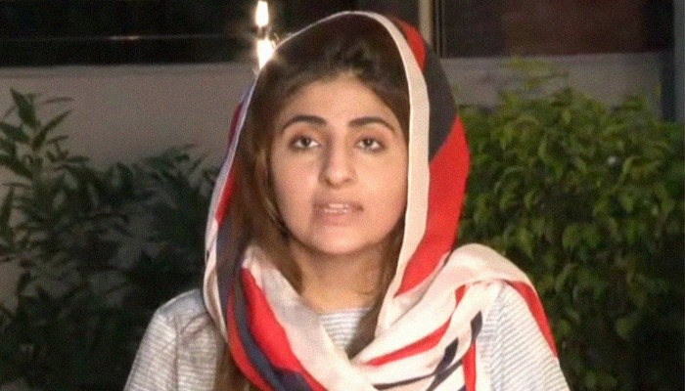The word has its origins from the word “Deep learning” belonging to the glossary of artificial intelligence. When artificial intelligence is used to impersonate someone, faking their visual appearance and even their voice to generate images and videos that are not real is termed as a Deepfake attack. These are fairly popular against Pakistani women as such attackers use this technology to create indecent videos, threatening to leak them. A popular target of such attacks or popular figures who have higher stakes with them concerning their reputation e.g., Fatema Sohail alleged that the indecent videos circulating online were created using Deepfake technology or someone impersonating her as she denies claims of her being in the video; backed up by FIA forensic report supporting her claims.

Image 3: Fatima Sohail interviewed after FIA backs up her defense

Denial of Service

When a virus or program infects your computer or your website, locking you out of its contents as well as stealing them, such attacks are called DoS attacks. This is a form of bullying fairly common on large scale level e.g., PIA’s was the target to a major DoS attack after their databases were compromised and place on sale for just $4000 on the dark web. Such attacks by rival countries/companies harm the integrity of the whole country. Although such attacks are fairly common on large scale level, individuals have also reported being locked out of their personal files after they unintentionally downloaded some virus. Such hackers harass consumers and demand money via bank transfer or Easypaisa/Jazzcash.

Hate Speech

Social media has overthrown the traditional media setups and its ability that allows anyone to appear to the whole world has been one that shapes many ideas and gives rise to new thinking. But when this is misused, to spread hate against a certain individual or a group, it can lead to not only mental torture but as well as physical harm too. Under Section 502(2) of the Pakistan Penal Code hate speech is criminalized and even punishable, 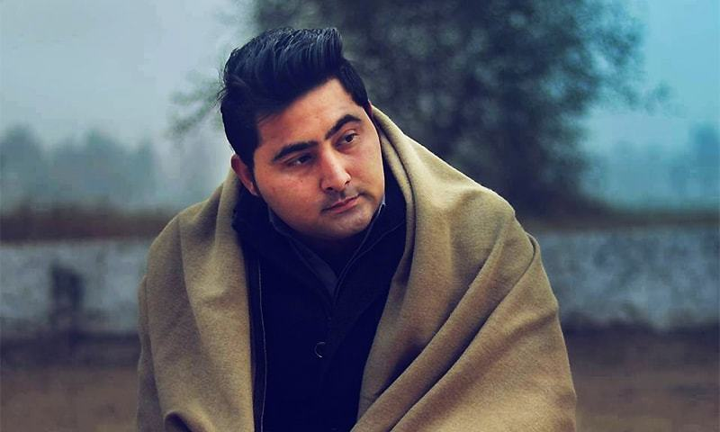but even still there are numerous cases of hate speech found online, most notably against political groups and religious minorities in Pakistan on Facebook. Consequence of hate speech led to incidents such as the Lynching of Mashal Khan over mere allegations of posting blasphemous content online with no proof.

Image 4: Deceased, Mashal Khan

Online Sexual Harassment

Women in Pakistan have been the greatest target to this type of cyber harassment. In fact, a report by a Pakistani NGO, DRF have found that 40% of women have experienced online sexual harassment, including being sent obscene media, threats and even catcalling online. They also concluded that 45% of these do not report these cases as they are embarrassed and another 47% thinks it’s not important. With the remaining 8% FIA registered 3027 cases in 2014-15 against online sexual harassment. This goes to show how traumatizing this form of harassment as women are reluctant as they do not trust how their information will be handled by the law enforcement agencies and they gulp it down. Many women ultimately reach a settlement with their harassers seeing no way out which permanently scars them for life.

Consequences of Cyber Harassment

Not only does cyber bullying leads to mental torture where a person falls victim to depression or anxiety, but it also leads to physical violence as cited above. Physical violence often leads to mass protests damaging property or murders/mob attacks on an individual. Mental torture includes a person feeling powerless, trapped and hopeless. This feeling of immense humiliation and isolation leads to them being overwhelmed and committing suicide.

Reporting Cyber Harassment in Pakistan

The Constitution of Pakistan guarantees protection against different forms of online harassment for example under article 14 the state is responsible for protecting the dignity of its citizens; but despite all this many people are unaware or hesitant on approaching the concerned authorities. If we report these crimes only then can cyber harassment be reduced. In Pakistan, you can do so by registering a complaint with:

1. Federal investigation agency (FIA)
2. Citizens-Police Liaison Committee (CPLC)

Psychological Harassment

Psychological harassment is defined as malicious or hostile behavior by one or more persons, directly or indirectly targeting a third person. It intends to attack or demean a person, and to isolate or exclude them by gradually forcing them out of their workplace or educational program. The events may appear harmless individually, but has a catastrophic effect on the target person.

Forms of Psychological Harassment

Psychological harassment has a much varied and subtle forms in every pace of life. It may include the acts that are intended to contravene in a person's ability to communicate, preventing them to express themselves. Social interaction, that is intended to harm a person, is also a form of psychological harassment. Attacking a person's reputation, humiliating them or insulting them is also a form of psychological harassment. These acts may harm a person's quality of life, and professional performance or carrier. One form of psychological harassment may include harming a person's health by giving a person, an excessive workload, or threatening a person.

Workplace Psychological Harassment

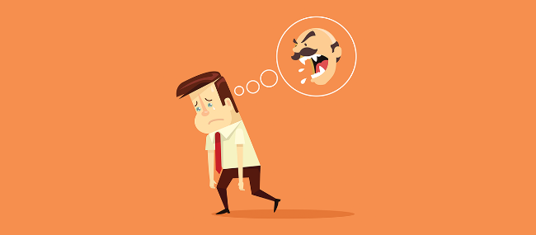Workplace harassment means belittling/threatening a worker or a group of workers. This implies demanding sexual favors in exchange of some benefit, or to avoid some detriment in the workplace. Another form of workplace harassment includes creating a hostile and demeaning environment that negatively affects person’s job performance. Inappropriate touching and sexual jokes are also included in this form.

Art 3: Workplace Harassment

Psychological Harassment in Educational Institutes

Harassment in educational institutes is very common and is on the rise. Children are prone to this kind of harassment. This seriously affects their mental health and cognitive capabilities. This may include intensive workload on children, hostile class environment, demoralizing and degrading children, or physically and mentally abusing them. In higher educational institutes, it may take some other forms too such as molesting pupils for higher grades or sexual favors. Bullying has also gained roots in our universities and schools, and the institutes doesn’t take the matter seriously.

Effects of Psychological Harassment

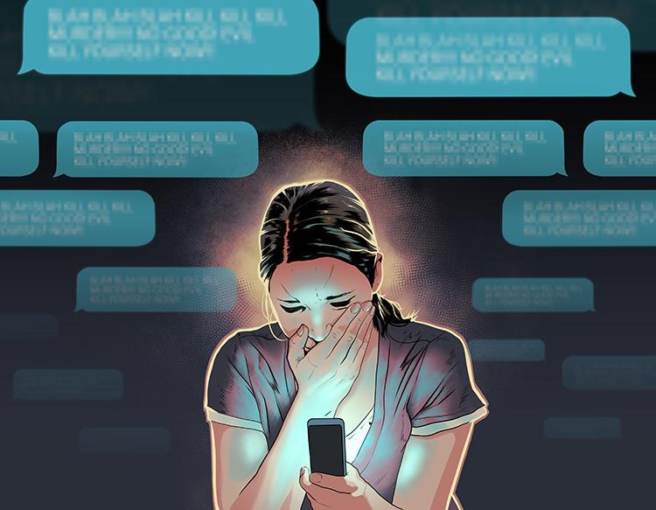Harassment is associated with increased risk of anxiety, depression and post-traumatic stress disorder, as well as diminished self-esteem and self-confidence, and psychological well-being. A research proves that harassment early in the career has long term effect on depressive symptoms in adulthood. Another research suggests that harassment leads to feelings of anger, self-blame and self-doubt. All in all, harassment of any sort crates long-term psychological and emotional problems in its victims.

Art 4: a woman feeling overwhelmed because of being psychologically harassed

Harassment – A new norm in Pakistan

In our society, workplace and educational institutes harassment is becoming more and more common. Usually, the investigations in such incidents are delayed; responsibilities are denied; facts are distorted and victims are disparaged. Ignorance, fear of liability, and a bad press is what make educational institutes and abusive offices turn a blind eye to their utmost obligation: providing safe and equal opportunity for everyone to work/study.

Moreover, although there are laws regarding rapists and harassers, the constitution does not give ample immunity against psychological harassment. That is the reason people feel emotionally drained in workplaces and psychologically upset at universities.

Thus, to conclude, we all have to change our perspective regarding psychological harassment and adopt a holistic approach to tackle the elephant in the room. Workplaces and universities should create more safe and secure environment for the employees/students. Strict legislation is required to criminalize psychologically hurting (affecting) someone.

Conclusion

The Government of Pakistan should introduce more efficient laws for harassment related issues while making sure that these laws are implemented. Furthermore, a chain of awareness campaigns should start using all sorts of media sources; as prevention is better then cure, we should target on educating the masses first. Indeed, if we respect the personal space of those around us and provide them the safety they are due, Pakistan is all set to become a great nation that our Quaid envisioned.

Bibliography

<https://www.tandfonline.com/doi/abs/10.1080/08974454.2019.1644697?needAccess=true&journalCode=wwcj20>

<https://thediplomat.com/2018/08/street-harassment-in-pakistan/>

<http://www.stopstreetharassment.org/resources/statistics/statistics-academic-studies/>

<http://www.pakistani.org/pakistan/legislation/1860/actXLVof1860.html>

<https://tribune.com.pk/story/1348833/93-pakistani-women-experience-sexual-violence>

<https://www.halaltrip.com/other/blog/the-prophets-last-sermon/>

shorturl.at/tzBSU (Ace News on Fatema Sohail Case)

shorturl.at/npxCP (PIA DoS attack)

https://dailytimes.com.pk/479203/hate-speech-in-pakistan/

https://english.alarabiya.net/en/News/world/2017/04/16/Who-was-Mashal-Khan-the-student-killed-in-Pakistan-

https://www.pakistantoday.com.pk/tag/hate-speech/

https://tribune.com.pk/story/2171675/harassment-cyberspace-online-crimes-continue-target-women (DRF on online sexual harassment)

shorturl.at/pENW1 (FIA report source)

Mohammad Ali Jinnah’s first Presidential Address to the Constituent Assembly of Pakistan (11 August 1947); http://www.columbia.edu/itc/mealac/pritchett/00islamlinks/txt_jinnah_assembly_1947.html

State of Human Rights in 2011, report of the Human Rights Commission of Pakistan, 2012, page 84: http://hrcp-web.org/publication/book/annual-report-2011-english

http://www.nytimes.com/2010/05/30/world/asia/30pstan.html?_r=1&

https://www.parhlo.com/6-ways-to-report-cyber-harassment-in-pakistan/

https://onlineharassmentfieldmanual.pen.org/defining-online-harassment-a-glossary-of-terms/